CYB102 Project 1 (🔗 Instructions Page)

👤 Student Name: Shireen M
✉️ Student Email:
Reflection (Required)

🤔 Reflection Question #1: If I had to explain “what are .pcap files” in 3 emojis, they would be…
(Feel free to put other comments about your experience in this unit here, too!)
🕵️ : someone is watching all secure data and capturing it secretly
📦 : packets of data being stored
🌐 : network traffic moving across the internet

🧠Reflection Question #2: How does Wireshark help us to analyze network traffic?
Wireshark allows us to capture and inspect every packet traveling across a network or over the internet in real time. It also allows to filter option with that we can filter by protocol (like in this lab we did using smtp), search within packet content (like smtp contains "FROM" or smtp contains "MAIL FROM") and read the actual payload of each packet making it possible to trace exactly who sent what, to whom, from which IP address and when.

📣 Shoutouts: Share appreciation for anyone who helped you out with this project or made your day a little better!
Shoutout to Google for helping me research concepts along the way and I verified my findings with Claude! During the last class lab and breakout session, we were provided separate files to practice TCP stream analysis, which gave me the foundation to apply those same techniques here and extract the email details from the pcap files.

Required Challenges (Required)

Item #1: The malicious actor's IP address:
In C.pcap found 10.6.1.104, this IP sent hundreds of phishing emails to Yahoo accounts in rapid succession a clear sign of a malicious spam/extortion campaign.

Item #2: The subject lines of three different phishing emails:
- Read carefully! - dayrit
- I can destroy everything! - 12345678
- Your password! - nafd111

Item #3: An explanation of how you went about finding the bad apple from just the .pcap files: (Please be specific about what filters/searches you used!)
1. Loaded all four pcap files and applied the smtp display filter in Wireshark as mentioned in the lab for week 1.

2. Applied smtp contains "FROM" to identify which packets contained outgoing email activity. Files A and D showed normal single-session emails that didn't seem anything suspicious.

3. File C had 1,661 packets compared to others a huge spike in the number of outgoing email packets. Filtering for smtp containing "MAIL FROM" revealed the same source IP 10.6.1.104 sending dozens of emails in rapid succession to different Yahoo addresses.

4. Inspected the DATA payloads. Every email followed the exact same extortion template: "Hi! I know that [password] is your password! Your computer was infected with my private malware..." with a Bitcoin wallet address for payment, while clearly showing a phishing mail.

5. Confirmed the attacker. All malicious traffic originated from 10.6.1.104 sending to Yahoo's mail server at 98.137.159.26 with Yahoo repeatedly responding 421 Too many concurrent SMTP connections confirming the attacker was flooding the server with emails.

Stretch Challenge (Optional)

Item #1: Three screenshots of three different .eml files showing the content of phishing emails you identified:
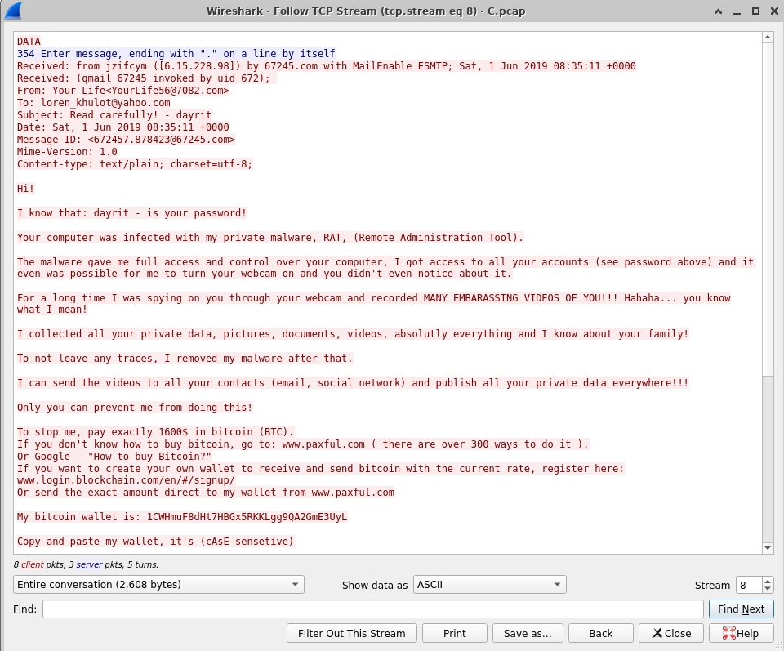

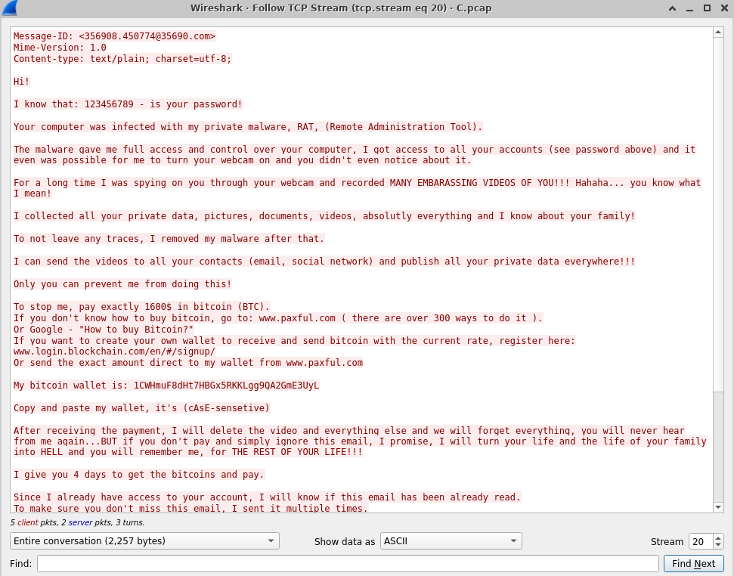

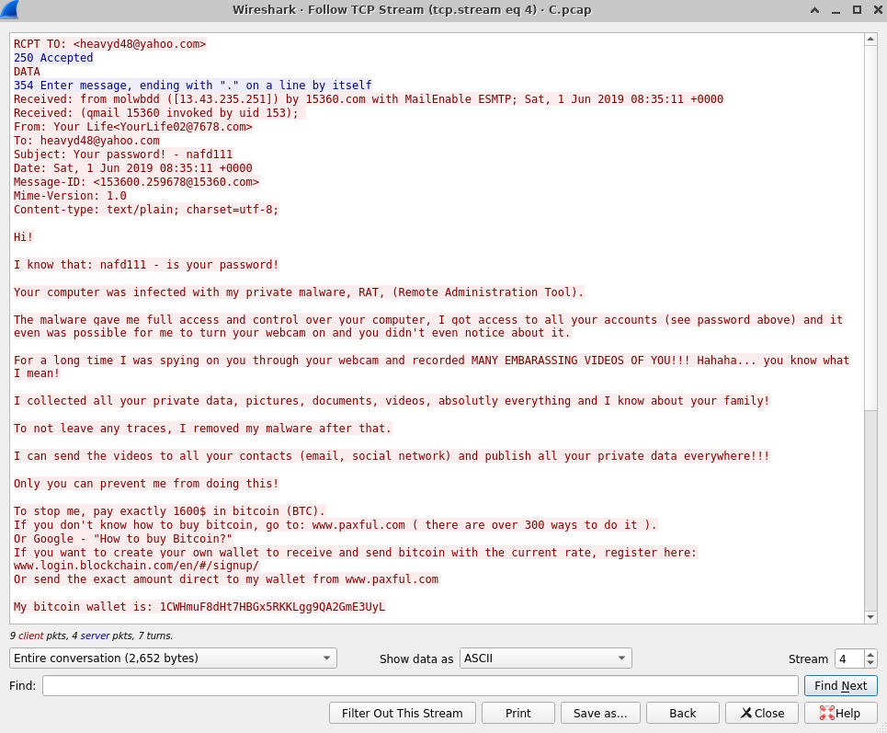
Notes (Optional): When I first opened C.pcap after opening file A&B pcap file was weird because it showed 1,661 packets that I wasn't expecting to see so I would say it's the first red flag. A and D had under 80 each.

Submission Checklist
👉Check off each of the features you have completed. You will only be graded on the features you check off.

Required Challenges
- Item #1
- Item #2
- Item #3

Stretch Challenge
- Item #1
💡Tip: You can see specific grading information, including points breakdown, by going to 🔗 the grading page on the course portal.

